 | تصویر | معرفی
 | 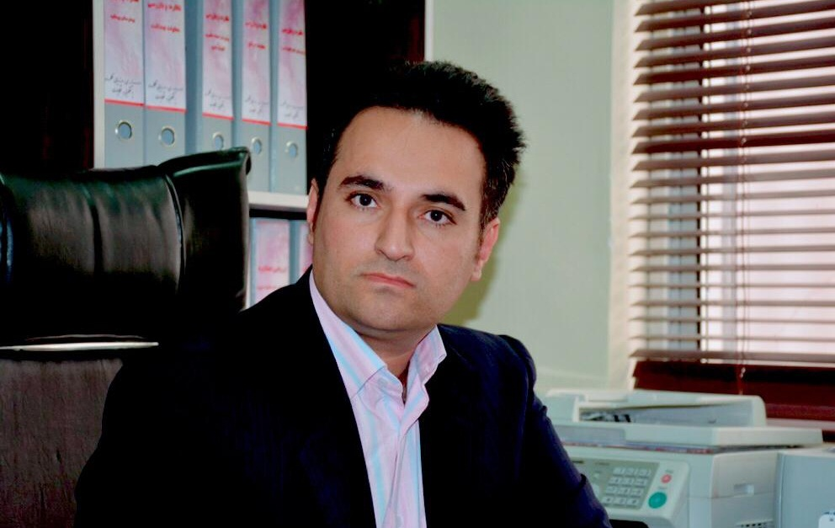 | نام و نام خانوادگی: دکتر محمد امین مهاجرانی
 |  | سمت: مدیر کلینیک تخصصی وفوق تخصصی هنری
 |  | تلفن مستقیم :۵۴۳۴۲۰۱۰-۰۷۱
 | سوابق :
Mohammad Amin Mohajerani

۱۹۸۳-۷-۲۹

PROFESSIONAL EXPERIENCES

۱۲ years of management experience in the private and public sectors, ۱۰ years of experience in teaching management at private and public universities.

Chairman of the Board of Trustees University of Medical Sciences. Iran / Nov ۲۰۱۴ – present
• Approval of internal regulations;
• Review and approval of the institution's budget;
• Approval of how to collect proprietary revenues and consumption;
• Determine Auditor and Treasurer for the institution;
• Approval of financial and trading regulations.

Member of the board of directors University of Medical Sciences. Iran / Nov ۲۰۱۴ – present
• Governing the organization by establishing broad policies and setting strategic goals;
• Selection of, appointing, supporting, and reviewing the performance of the executive officers;
• Setting the salaries and benefits of personnel.

Representative of the Ministry of Health and Medical Education, Deputy Director of Planning, Steering and Affairs Ministry of Health and Medical Education. Iran/ Aug ۲۰۱۶ – present
• Signification of Approvals of Planning Deputy;
• Manage of the Permanent Commission of the University.

Head of the Office of Inspection, Performance Evaluation University of Medical Sciences. Iran /Oct ۲۰۱۴ – present
• providing factual and analytical information;
• measuring performance;
• determining compliance with applicable law, regulation, and / or policy
• identifying savings and funds put to better use;
• sharing best practices or promising approaches;
• Evaluating allegations of fraud, waste, abuse, and mismanagement. Special Supervisor Manager University of Medical Sciences. Oct ۲۰۱۴ – present
• Evaluating of the quality of health care centers.

General Manager Amin Home property agency. Iran/Apr ۲۰۰۶– present
• Managing the sale and buy of real estate, villas and gardens;
• Financial Management.

Professor of General Management Courses Payam Noor University. Iran/Oct ۲۰۰۸– ۲۰۱۶
• Teaching Management Courses) development management, English for manager, Management of Organizational Behavior, Management of Human Resources, Managing organizational change, Team building and ……);
• Supervisor of management Student Theses.

Professor of Development Management course Andishe University. Iran/Sep ۲۰۱۴-۲۰۱۵
• Teaching Development Management course.

Professor of Health management Courses University of medical Sciences. Sep ۲۰۰۸– present
• Teaching Management Courses (Nursing Management, management of Hospital and …). Administrative affairs expert The Fars Provincial Court of Justice. Iran/ Jan ۲۰۰۵–۲۰۰۶
• Assistant Attorney at court.

Hotel Manager FatholMobin Hotel. Iran/ Mar ۲۰۰۹–۲۰۰۹
EDUCATION
Swedish EBS Center
Doctorate of Business Administration
College of Management. University of Payame Noor Jahrom.Iran
• BS in Administrative management. Field of Human Resource

College of Management. University of Azad Rafsanjan .Iran
• Master in Management. Field of Human Resource

SKILLS CRITICAL BEHAVIOR
•
Manage multiple sections simultaneously Discipline
•

Strong Leadership skills and ability to work as team High work Ethics

•

Strong administrative and writing Skills Trustworthy and Honest
•

Being good in IT commitment

• Deliver results on time
• Able to work under pressure
• Flexibility
• Fluent in English
• Beginner in French
ADDITIONAL INFORMATION: Author of Book of Quality of Work Life and Employees Organizational Participation

